**What happened in 1920s and 1930s Mandate Palestine?**

**Lesson 5**

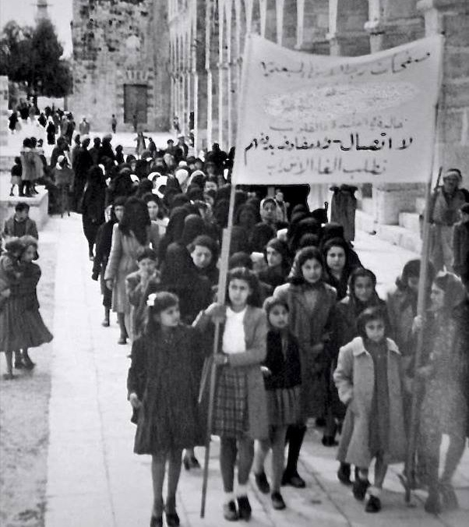

Palestinian women’s activism during the British Mandate

**By the end of this lesson, you should be able to:**

Outline the political situation in 1920s and 1930s Mandate Palestine

Explain the increasing tension between Palestinians and Jews at this time

Give some examples of the unrest that occurred during this period

**Keywords**

Arab Executive

Jewish Agency

Jewish National Council

Yishuv

Arab Revolt of 1936-1939

**Knowledge check!**

1)What was ‘Mandate Palestine’?

2)Why was there a Mandate for Palestine?

3)How long did Britain govern Palestine for?

**Modernisation in Mandate Palestine**

Building on its advancements from the nineteenth century, Palestine went through a period of modernisation in the 1920s and 1930s. The Jaffa Electric Company was founded in 1923, and there were major advancements in travel across Palestine. The Palestine railways were developed, and in December 1934, Palestine Airways was founded. In August 1937, Palestine Airways commenced commercial flights from Haifa to Lydda three times each week

The status of women was also increasingly discussed in the Palestinian (and Arabic) press at this time. Jaffa’s *Filastin* from Lesson 3regularly published on this topic, with titles *including ‘The Veil and the Duty to Lift It’* and *‘The Necessity to Liberate Women’*

**The political situation: the British**

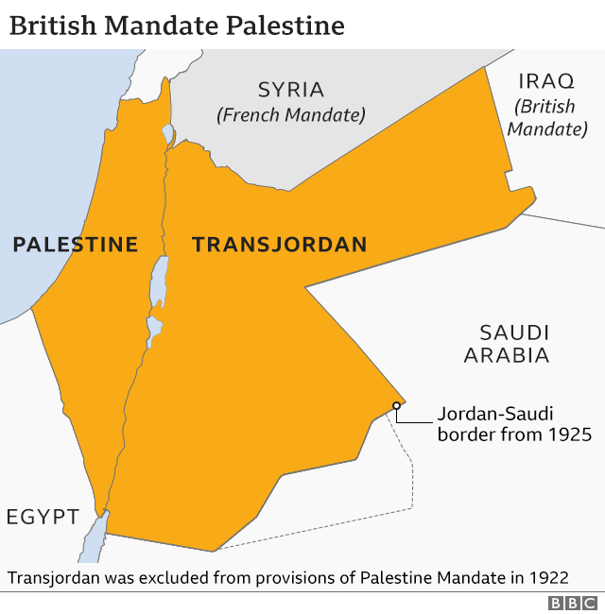

As we saw last lesson, the Palestine Mandate was split into *Mandate Palestine* and *Mandate Transjordan* in 1922

Although Palestine was technically a Mandate, British governance of Palestine was quite **colonial in nature.** The British Administration in the country reported to the **Colonial Office**, and the system of government was based on the **‘traditional hierarchy’ of the British Crown colonies**

There were multiple levels to the British Administration in Mandate Palestine:

-High Commissioner

-An Executive Council of high-ranking officials

-A mixed Advisory Council with no executive authority

-A country-wide Civil Administration, the senior ranks of which were occupied by British men, with more junior positions distributed among Palestinians and Jews

Overall, British policy in Mandate Palestine was characterised by **ineffectiveness** and **instability**, as Britain found itself being pulled in different directions by the Palestinians and Zionists

**The political situation: the Palestinians**

At first, **Muslim-Christian Associations** were established across Palestine. In 1919, these associations came together to establish the **Palestine Arab Congress.** At the third Palestine Arab Congress, the **Arab Executive** was established. This became the **main Palestinian nationalist group** in 1920s Palestine. Then, at the start of the Great Arab Revolt in 1936, the Arab Executive was replaced with the **Arab Higher Committee**

What did Palestinians want? The Palestinians had been promised their **independence** for rising up against the Ottoman Empire – they wanted a **Palestinian state**!

**The political situation: the Zionists**

At the First Zionist Congress in Basle in 1897, the **Zionist Organisation** was established. The Zionist Organisation led the Jews in Palestine until 1929, when the **Jewish Agency** was established as a **branch** of this organisation. Another important Zionist organisation was the **Jewish National Council** (or *Vaad Leumi*). This was the **main organisation** concerning Jewish welfare, education, local government and security in Mandate Palestine

What did Jews want? The Jews had been promised British support for the establishment of a ‘**national home**’ in Palestine-Israel – they wanted a **homeland**!

**The daily lives of Palestinians and Jews**

On a **daily level**, Palestinians and Jews lived quite **separate lives** during the Mandate. The communities were separate for **education, health and culture**. For example, **98.8%** of students at Christian missionary schools were Palestinian in 1926 – just 1.2% were Jewish. The Jewish community had its own **independent school system**. The Palestinian and Jewish communities were also quite distinct from each other in terms of **economy** and **law**

**Knowledge check!**

Why is Palestine-Israel (specifically Jerusalem) significant to Jews?

**Jewish immigration to Mandate Palestine**

Jewish immigration to Mandate Palestine was one of the **main sources** of tensionbetween Palestinians and Jews in the 1920s and 1930s. The word ‘Aliyah’ is often used to describe the movement of Jews to Palestine-Israel. There have been several waves of this:

**-Pre-1882:** most Jewish immigrants to Palestine-Israel settled in Jerusalem, Hebron, Tiberias or Safed

**-First Aliyah, 1882-1903:** rather than settling in cities, these mostly Russian Jews settled in towns such as Jaffa and Haifa and founded agricultural settlements

**-Second Aliyah**, **1903-1914:** took the *Yishuv* population from 55,000 in 1900 to 85,000 in 1914

During the Mandate period, Jewish immigration continued. By 1931, the Jewish population in Palestine had almost **doubled** to 175,000. And then between 1933 and 1935, 135,000 Jews arrived. Most of these Jews werefleeing **Nazi Germany and Poland**

**Mandate Palestine population**

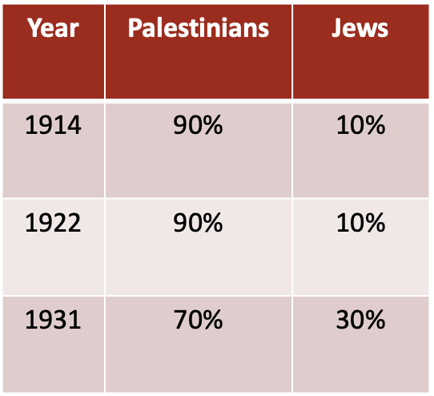

**The Palestinian reaction to Jewish immigration**

Jewish immigration to Mandate Palestine was problematic for Palestinians. The **Jewish Agency** helped Jewish immigrants buy land in Mandate Palestine, and land purchased by the Jewish National Fund was leased **exclusively to Jews**. Palestinians felt that they were losing their land and that their chances of a Palestinian state were slipping away. This came to a head with the **Arab Revolt of 1936-1939**, a nationalist uprising of Palestinian Arabs against the British administration

**Debating activity**

**Support for Jewish immigration to Mandate Palestine**

Ideas:

-Jews had been promised British support for a national home in Palestine-Israel under the Balfour Declaration, which had been incorporated into the Mandate. Britain must now honour this promise and facilitate Jewish immigration to Mandate Palestine

-After facing antisemitism for centuries, Jews were once again being treated disgracefully in Nazi Germany and across Europe: they needed a homeland now more than ever!

**Opposition to Jewish immigration to Mandate Palestine**

Ideas:

-Palestinians had been promised an independent state for rising up against the Ottoman Empire. As the British supported Jewish immigration to Mandate Palestine, this independent Palestinian state became increasingly unlikely

-The British have a responsibility as Mandatory power to uphold the rights of the Palestinians who have lived on this land for centuries – it is their homeland!

**5c. Unrest in 1920s and 1930s Mandate Palestine**

On 25th April 1920, the Mandate for Palestine was provisionally granted to Britain at the San Remo conference in Italy. Earlier in the month, the Nebi Musa Riots had taken place in Jerusalem. Between the 4th and 7th April, large crowds of Palestinian Muslims gathered at the religious festival of Nebi Musa, and some of the speeches mentioned Zionist ambitions in Palestine-Israel. This escalated into violence against Jews, with 5 Jews and 4 Palestinians killed, and hundreds more injured. The Nebi Musa Riots significantly worsened the relationship between Palestinians and Jews at the very start of the Mandate period.

Just one year later in 1921, the Jaffa Riots took place. In the first week of May, rioting started in Jaffa and spread to Abu Kabir and other parts of Mandate Palestine. The violence began as a fight between two Jewish groups (the Jewish Communist Party and a rival Jewish socialist group) but it was misreported as attacks by Jews on Palestinians. This led to attacks by Palestinians on Jews and attacks by Jews on Palestinians. 47 Jews and 48 Palestinians were killed, with another 146 Jews and 73 Palestinians wounded. High Commissioner Herbert Samuel had to call in reinforcements from Egypt to restore peace.

In late August 1929, in the context of rising tensions over Jewish immigration to Mandate Palestine, demonstrations and riots occurred regarding access to the Western Wall in Jerusalem. The Western Wall is an important site for Jews because it is the holiest place where Jews can pray. It is a similarly important site for Muslims because it is part of Al-Aqsa Mosque, the third holiest site in Islam. The violence spread to Hebron, Jaffa and Safed, with 166 Palestinians and 133 Jews killed. 232 Palestinians and 339 Jews were injured. Some say that the events of 1929 destroyed any chance of peace between Palestinians and Jews.

The Arab Revolt of 1936-1939 was a nationalist uprising of Palestinian Arabs against the British administration of the Palestine Mandate. It started with a general strike and nationwide demonstrations against British rule and British support for Jewish immigration to Mandate Palestine. It turned into three years of instability across the country, during which, for long stretches of the rebellion, the British lost control of Palestine. Historian Elizabeth Brownson has described this as “the most disruptive Palestinian uprising during the British Mandate”. By the end of the revolt, 10% of Palestinian men had been killed, wounded or exiled. An investigation at the start of the uprising concluded that Mandate Palestine must be partitioned. We’ll return to this idea of partition in a future lesson.

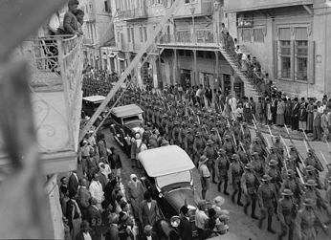

**Extension activity**

Create a spider diagram of life in 1920s and 1930s Mandate Palestine

You might want to include:

-The political situation

-Some examples of violence

-Context on Jewish immigration

-The Palestinian reaction to Jewish immigration

-Examples of modernisation in Palestine

Compare this with your spider diagram of life in nineteenth century Palestine-Israel from our first lesson. **What has changed and what has stayed the same?** Write a paragraph about this

**Check your knowledge!**

Why was there increasing tension between Palestinians and Jews at this time?

Can you give two examples of unrest that occurred during this period?